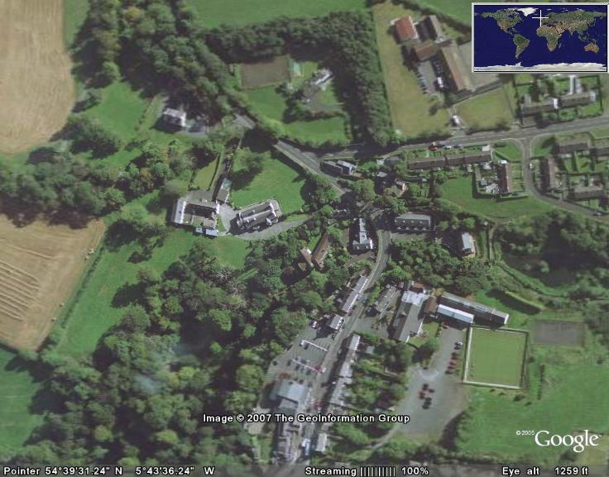

The Old Inn

Courtyard Cottage

Crawfordsburn Village
Cootehall Road

Location of Courtyard Cottage

Turn of the main Belfast to Bangor Road (A2) at Ballyrobert Road (B20) signposted for Crawfordsburn .

Proceed into the village (1 Mile) passing the Old Inn on the left.

Follow the white line as shown above, rounding the bend, passing the junction with Cootehall Road on the right . Courtyard Cottage is the next turn immediately on the left with the house name on the left hand entrance post.

If arriving after dark lookout for a red reflector marking the entrance. Take care as the turn into the property is quite tight, proceed slowly straight down the drive keeping to the left. Courtyard Cottage is immediately in front of you.

To return to site

